Designing and Implementing LED Control Sequences using ATmega32 Microcontroller

Aim

The goal of this project was to design and simulate several LED light patterns—including blinking, chasing, and converging sequences—using an ATmega32 microcontroller. I carried out these designs within the Proteus 8 Professional environment to verify the logic and timing before any physical implementation.

Tools Used
- Software: Proteus 8 Professional (for circuit design and logic simulation).
- Components Simulated: ATmega32 Microcontroller, LED-AQUA, and 270Ω Resistors.

Theory
- The ATmega32 Microcontroller The ATmega32 is an 8-bit chip built on Harvard architecture. It features separate paths for instructions and data, which helps it process commands quickly. It does not use cache memory in its Arithmetic Logic Unit (ALU). Controlling the Output:
- To make the LEDs work, I had to interact with two main registers: DDRA (Data Direction Register A): I set this to 0xFF to instruct the microcontroller that all pins on Port A should act as outputs. PORTA (Data Register): This register controls the actual state of the pins. Sending a "1" turns the light on, and a "0" turns it off.
Procedure
These are the codes I used to create the different lighting effects in the Proteus simulation. I have removed all comments to keep the code clean.
1. Basic All-LED Blink
int main(void) {
DDRA = 0xFF;
while (1) {
PORTA = 0xFF;
_delay_ms(1000);
PORTA = 0x00;
_delay_ms(1000);

}
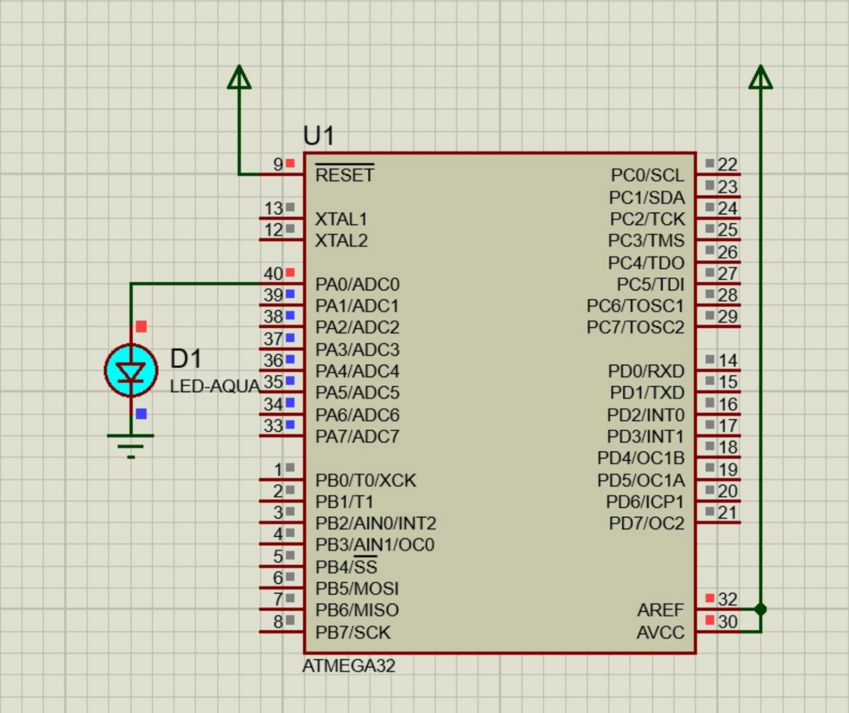
2. The Sequential Chaser
int main(void) {
uint8_t i;
DDRA = 0xFF;
PORTA = 0x00;
while (1) {
for(i=0; i<8; i++) {
PORTA = (1 << i);
_delay_ms(500);
}
_delay_ms(1000);
PORTA = 0x00;
_delay_ms(1000);
}
}
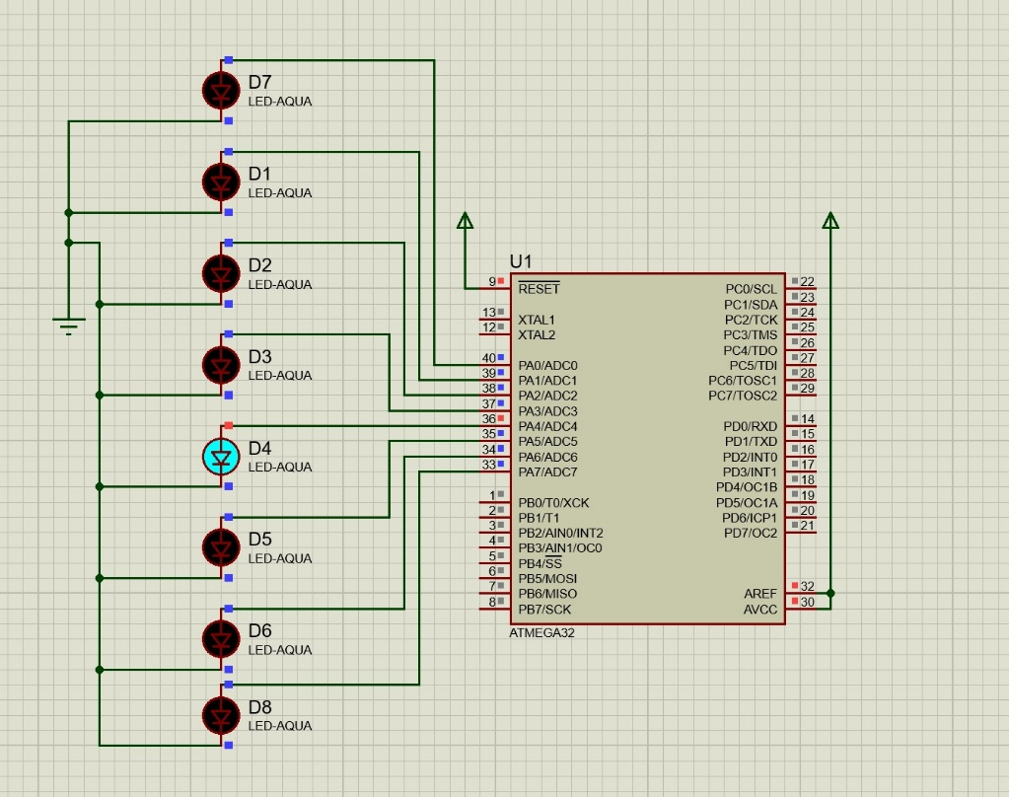
3. Alternating Pattern
int main(void) {
uint8_t i;
DDRA = 0xFF;
PORTA = 0x00;
while (1) {
for(i=0; i<8; i = i + 2) {
PORTA = (1 << i);
_delay_ms(500);
}
_delay_ms(1000);
PORTA = 0x00;
_delay_ms(1000);
}
}
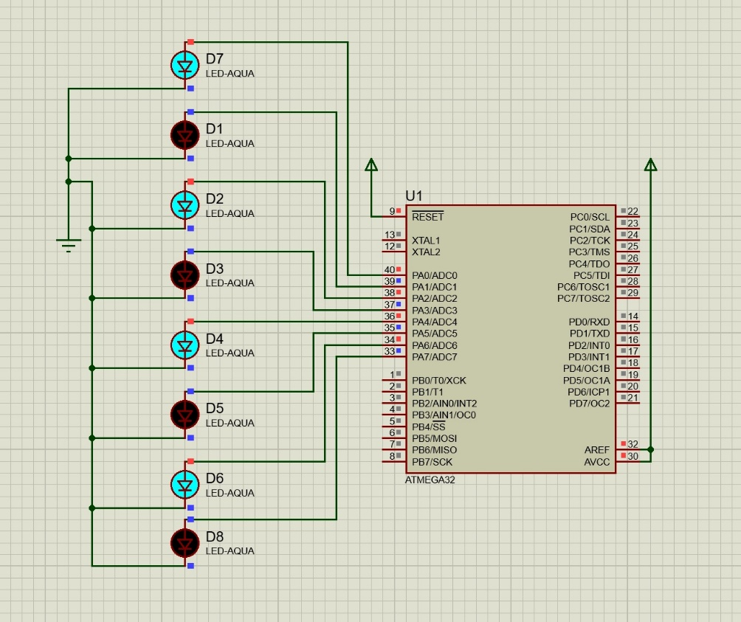
4. Converging Pattern (Ends to Middle)
This visual starts with the outer LEDs and works its way inward to the center lights.
C
int main(void) {
DDRA = 0xFF;
PORTA = 0x00;
while (1) {
PORTA = 0b10000001;
_delay_ms(500);
PORTA = 0b01000010;
_delay_ms(500);
PORTA = 0b00100100;
_delay_ms(500);
PORTA = 0b00011000;
_delay_ms(500);
PORTA = 0x00;
_delay_ms(1000);
}
}
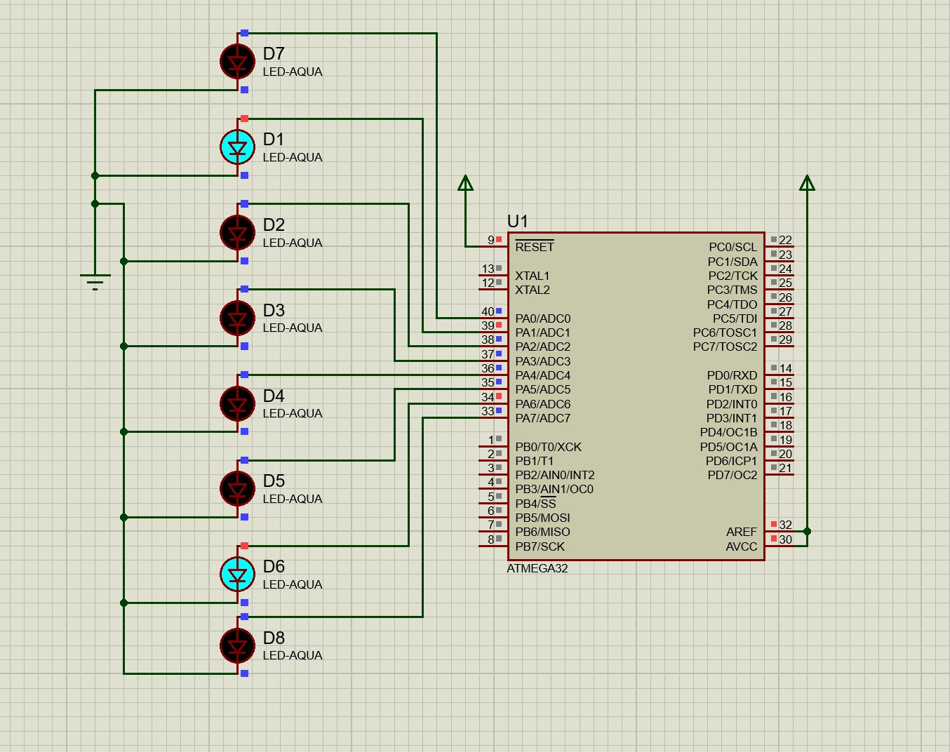

5. AVR GCC
#define F_CPU 8000000UL
#include <avr/io.h>
#include <util/delay.h>

int main(void)
{
DDRA = 0xFF;

while(1)
{
for(int i = 0; i < 8; i++)
{
PORTA = (1 << i);
_delay_ms(300);
}
for(int i = 6; i >= 1; i--)
{
PORTA = (1 << i);
_delay_ms(300);
}
}
}

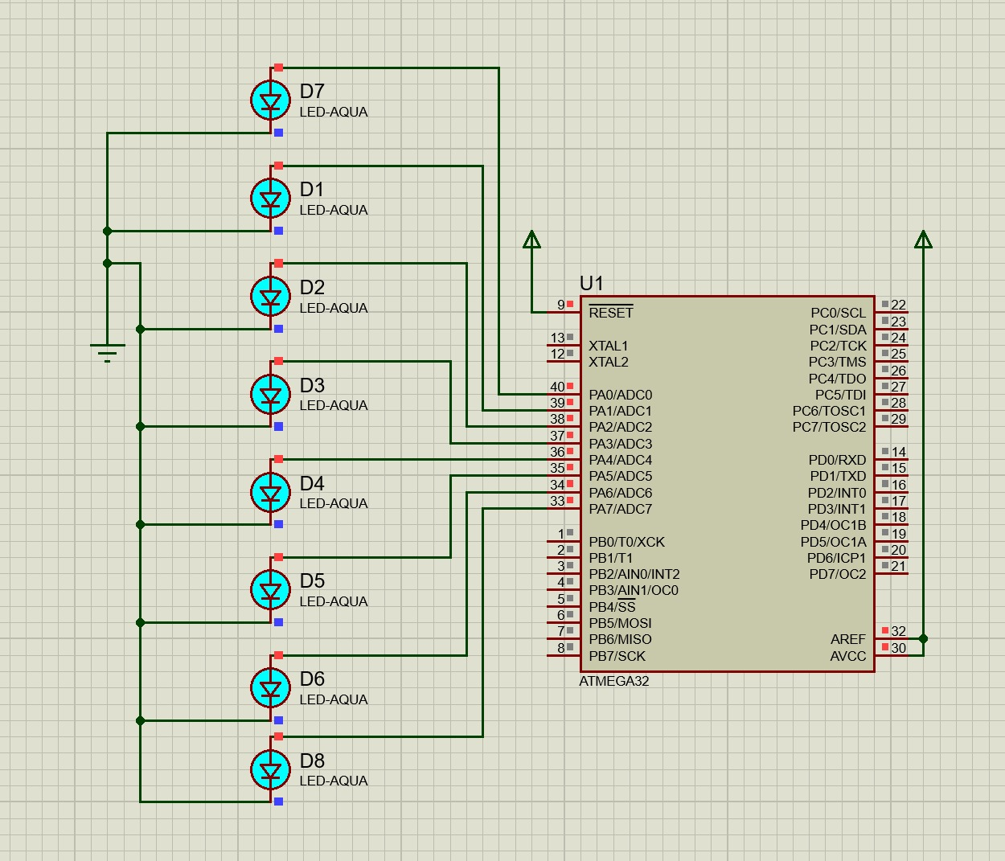

Result
In the Proteus simulation, the ATmega32 executed each sequence correctly. By changing the binary values in PORTA, I was able to confirm that specific pins (PA0 through PA7) turned on exactly when I expected. I found that using a loop for the "chaser" was much more efficient than writing out each step by hand. The software simulation showed that the timing provided by _delay_ms was enough for the human eye to see the lights moving..

Conclusion
This lab successfully demonstrated how to control hardware through code with an AVR microcontroller. By simulating the circuit in Proteus, I could test and fix my logic for various patterns, like the alternating and converging sequences, without needing physical hardware. This shows how microcontrollers can be programmed to manage complex signaling tasks in an Industry 3.0 or 4.0 setting.

